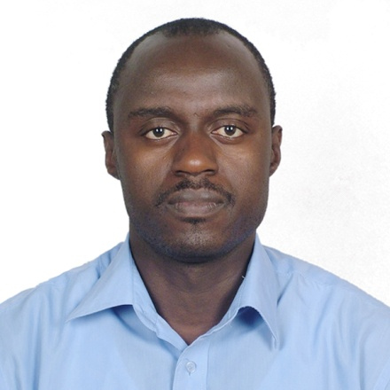

**Theoneste NZAYISENGA| Deputy Managing Director**

**M.Eng in Petroleum Engineering**

Theonestewas appointed Deputy Managing Director for SDS.ltd since August 2012 with responsibility also as the co-founder together with Dr. Gabriel. I am in labor market since 1999 when I graduated from secondary school but interrupted working periods with studies on many occasions. I worked for different public and private institutions before the establishment of SDS.ltd. I worked at National University of Rwanda (NUR) as a research assistant and laboratory technician for nearly two year since 2007. At the Ministry of infrastructure I was in charge of monitoring the stability of Lake Kivu throughout extraction process of methane gas from 2008-2009. I worked as a volunteer in different local NGOs like Association pour la Conservation de la Nature au Rwanda (ACNR), Association Rwandaise des Ecologistes (ARECO-RWANDA NZIZA) and Association pour la Promotion des Etudes d’Impact Environnementaux Au Rwanda (APEIER). I am giving some training of EIA to local professionals and partially teaching Environmental courses in a local University. I am holding a BSc. in Biology especially Zoology from National University of Rwanda since 2007 and a Master of Engineering in Oil and Gas Field Development from China University of Geosciences since 2011. I am motivated by my versatile skills in science and Engineering. One maybe astonished by how I have been moved by the engineering wind to oil and gas sector but am feeling so comfortable in both area; reconciling environmental protection and natural resource exploitation.

Innovation, self motivation, team spirit and time respect these are strengths at the service delivery.